24AIM:- Develop a system using UML for Online Stock Market System. This System facilitates its users the trade (i.e. buying and selling) stocks online. It allows clients to keep track of and execute their transactions of the different stocks in their portfolios. The central system should keep track of all the users, who interact with the system.

CLASS DIAGRAM: 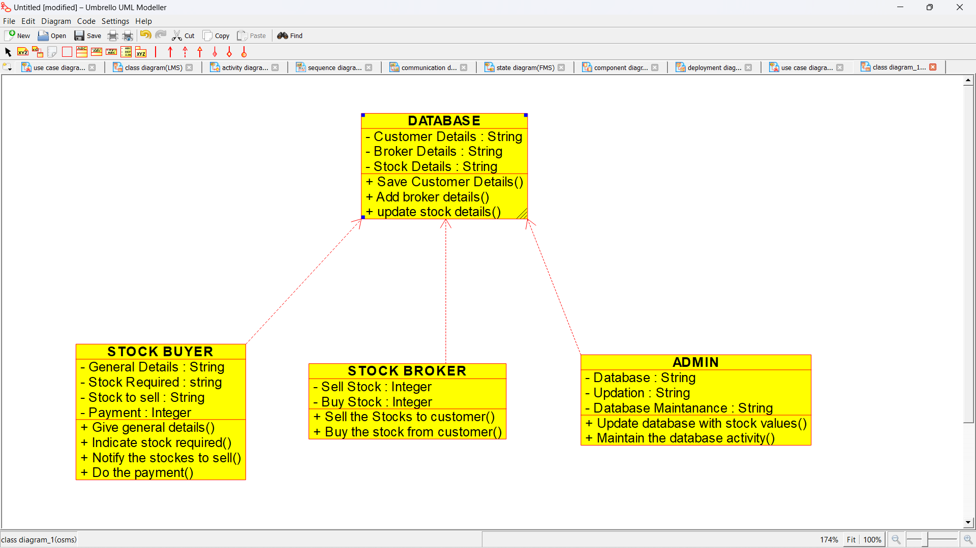

SEQUENCE DIAGRAM:

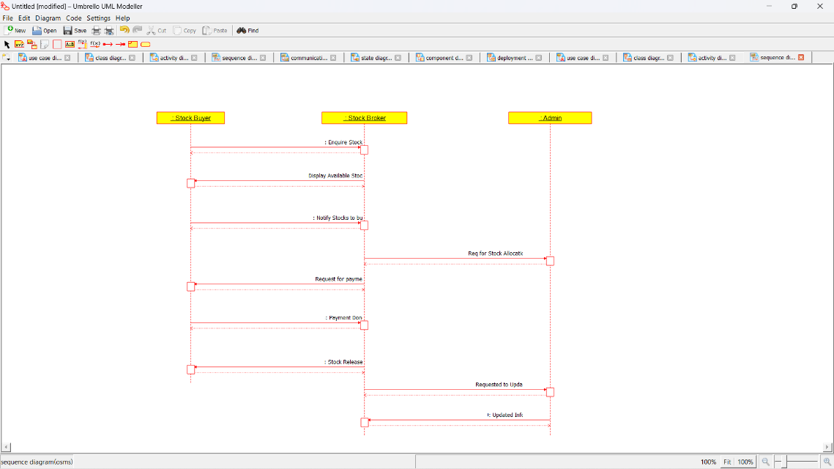

COLLABORATION DIAGRAM:

